 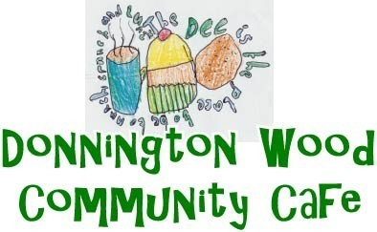 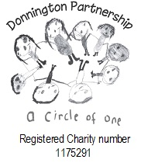

Donnington Community Hub

St Matthews Road

Donnington

Telford TF2 7PR

Tel: 01952 382203

New Mobile 07539758533

September

|  |  |
| --- | --- |
| **Week 1 1st** | **Week 2 8th** |
| **Roast Beef Dinner**  **Cheese & Onion Quiche**  **Sausage Casserole**  **Jam Sponge**  **Fruit Crumble**  **Jelly & Ice Cream** | Roast Chicken Dinner  Cottage Pie  Vegetable Pie  Syrup Sponge  Semolina Pudding  banana split |
| **Week 3 15th** | Week 4 22nd |
| **Roast Gammon Dinner**  **Steak & Kidney Pie**  **Cheese & Potato Pie**  **Lemon Sponge**  **Rice Pudding**  **Fruit Flan** | Roast Pork Dinner  Macaroni Cheese  Corned Beef Hash  Fruit Sponge  Eton Mess  Apple Pie |
| **Week 5 29th** |  |
| **Roast Lamb Dinner**  **Beef Stew & Dumplings**  **Vegetable Lasagne**  **Chocolate Sponge**  **Jam Tart**  **Egg Custard Tart** | The sponges can be made gluten free if we know in advance |

Also available on request. Jacket potato with the dinner, or as a dinner with a filling and salad. Gammon or Salmon with parsley sauce, and for dessert, cheese and biscuits, Trifle or fresh fruit salad.

Food Allergies and Intolerances. Please ask a member of staff