 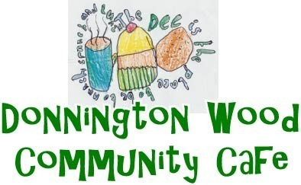 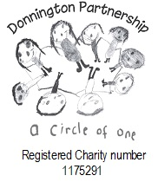

Donnington Community Hub

t Matthews Road

Donnington

Telford TF2 7PR

Tel: 01952 382203

**New Mobile 07539758533**

**November**

|  |  |
| --- | --- |
| Week 1 3rd | Week 2 10th |
| Roast Beef Dinner  Cheese & onion Quiche  Fish & Chips mushy peas  Jam Sponge  Bread & Butter Pudding  Fruit Cocktail & Cream | **Roast Pork Dinner**  **Vegetable Curry**  **Cottage pie**  **Fruit Sponge**  **Apple Crumble**  **Manchester Tart** |
| Week 3 17th | **Week 4 24th** |
| Roast Gammon Dinner  Vegetable Lasagne  Fish Pie  Lemon Sponge  Banoffee Pie  Bakewell Tart | **Roast** **Chicken Dinner**  **Vegetable Pie**  **Carbonara (Gluten Free Available)**  **Syrup Sponge**  **Fruit Flan**  **Cherry Pie** |
|  |  |
|  | We are offering frozen meals made to order over the Christmas period, but the must be order by the first week in November so that we know how many to cook for. |

**Also available on request. Jacket potato with the dinner, or as a dinner with a filling and salad. Gammon or Salmon with parsley sauce, and for dessert, cheese and biscuits, Trifle or fresh fruit salad.**

Food Allergies and Intolerances. Please ask a member of staff