 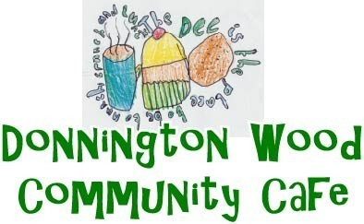 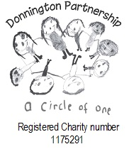

Donnington Community Hub

St Matthews Road

Donnington

Telford TF2 7PR

Tel: 01952 382203

**New Mobile 07539758533**

**October**

|  |  |
| --- | --- |
| Week 1 6th | Week 2 13th |
| Roast Chicken Dinner  Cheese & Tomato Flan  Sausage & Mash  Lemon Sponge  Fruit Flan  Jam Roly Poly | **Roast Beef Dinner**  **Vegetable Curry**  **Chicken & Mushroom Pie**  **Syrup Sponge**  **Rhubarb Crumble**  **Jelly & Ice Cream** |
| Week 3 20th | **Week 4 27th** |
| Roast Pork Dinner  All Day Breakfast  Broccoli & Stilton Quiche  Fruit Sponge  Rice Pudding  Treacle Tart | **Roast Gammon Dinner**  **Macaroni Cheese**  **Chicken Casserole**  **Jam Sponge**  **Angel Delight**  **Spotted Dick** |
| All day Breakfast 2 bacon, 2 sausage, mushroom, baked beans, scrambled egg, hash brown. |  |
|  |  |

**Also available on request. Jacket potato with the dinner, or as a dinner with a filling and salad. Gammon or Salmon with parsley sauce, and for dessert, cheese and biscuits, Trifle or fresh fruit salad.**

Food Allergies and Intolerances. Please ask a member of staff